|  |  |
| --- | --- |
| **WEBSITE DESIGN WITH JQUERY ACTIONS** | **Ex. No: 7** |
| **07/09/2023** |

# Aim

# To create web page using HTML, CSS, JQuery actions.

# Description

jQuery actions encompass the dynamic and interactive features that can be seamlessly AngularJS Architecture

AngularJS is a Single Page Application (SPA) meta-framework. Angular JS follows the MVC

architecture. MVC stands for Model-View-Controller evolved as a way to separate data, logical units

and presentation in web application development.

• The model is the driving force of the application. This is generally the data behind the

application, usually fetched from the server.

• The view is the UI that the user sees and interacts with. It is dynamic, and generated based on

the current model of the application.

• The controller is the business logic and presentation layer, which performs actions such as

fetching data and makes decisions such as how to present the model, which parts of it to display,

etc.

AngularJS Extends HTML

• AngularJS extends HTML with ng-directives.

• The ng-app

o directive defines an AngularJS application

• The ng-init

o directive used to create initial value(model) for the angular JS application.

• The ng-model

o directive binds the value of HTML controls (input, select, textarea) to application

data.

• The ng-bind

o directive binds application data to the HTML view

**Program**

<!DOCTYPE html>

<html lang="en">

<head>

<meta charset="UTF-8">

<meta name="viewport" content="width=device-width, initial-scale=1.0">

<title>cake shop</title>

<script src="https://ajax.googleapis.com/ajax/libs/jquery/3.6.4/jquery.min.js"></script>

<script >

$(document).ready(function(){

$('#btn').click(function(){

var n=parseInt($('#c1').val());

var cake1=n*300;

var a=parseInt($('#c2').val());

var cake2=a*300;

var b=parseInt($('#c3').val());

var cake3=b*300;

var i=parseInt($('#c4').val());

var cake4=i*300;

var order=cake1 + cake2 + cake3 + cake4;

$('#o1').val("Rs."+ order);

})

})

</script>

<style>

*{

margin:0px;

}

h1{

background-color:rgb(238, 98, 17);

color:white;

}

.b5{

word-spacing:300px;

}

.order{

color:rgb(69, 77, 143);

font-weight: bold;

padding-left: 500px;

}

#c1,#c2,#c3,#c4{

width: 550px;

border-width: 3px;

height: 30px;

border-radius: 5px;

}

#btn{

background-color: rgb(17, 215, 230);

border-radius: 5px;

}

</style>

</head>

<body>

<h1><center>CAKE SHOP</center></h1>

<div>

<img src="https://www.theflowerspoint.com/data/cache/images/cakes/rainbow-cake/rainbow-round-cake-441x441.jpg" width="400px" height="280px">

<img src="https://www.fnp.com/images/pr/l/v20221205202745/chocolate-rose-designer-cake-1-kg_1.jpg" width="380px" height="280px">

<img src="https://faridabadcake.com/wp-content/uploads/2023/03/luscious-choco-vanilla-cake.jpg" width="380px" height="280px">

<img src="https://www.cakehut.in/image/cache/catalog/2021%20cake%20photos/Double%20Chocolatee-600x600w.jpg.webp" width="340px" height="280px">

</div>

<div class="b1"></div>

<div class="b2"></div>

<div class="b3"></div>

<div class="b4"></div>

<div class="b5">

<label><b>Rainbow-Cake-Rs.300</b></label>

<label><b>Brown-Cake-Rs.300</b></label>

<label><b>White-Cake-Rs.300</b></label>

<label><b>Black-Cake-Rs.300</b></label>

</div>

<br>

<br>

<center><h2>ORDER CAKE</h2></center>

<div class="order">

<br>

<label>Rainbow cake[Quantity]</label>

<br>

<input type="text" id="c1" >

<br>

<br>

<label>Brown cake[Quantity]</label>

<br>

<input type="text" id="c2">

<br>

<br>

<label>White cake[Quantity]</label>

<br>

<input type="text" id="c3">

<br>

<br>

<label>Black cake[Quantity]</label>

<br>

<input type="text" id="c4">

<br>

<br>

<button id="btn" >ORDER</button>

<br>

<br>

<label>TOTAL BILL:</label> <input type="text" id="o1">

</div>

</body>

</html>

**Output**

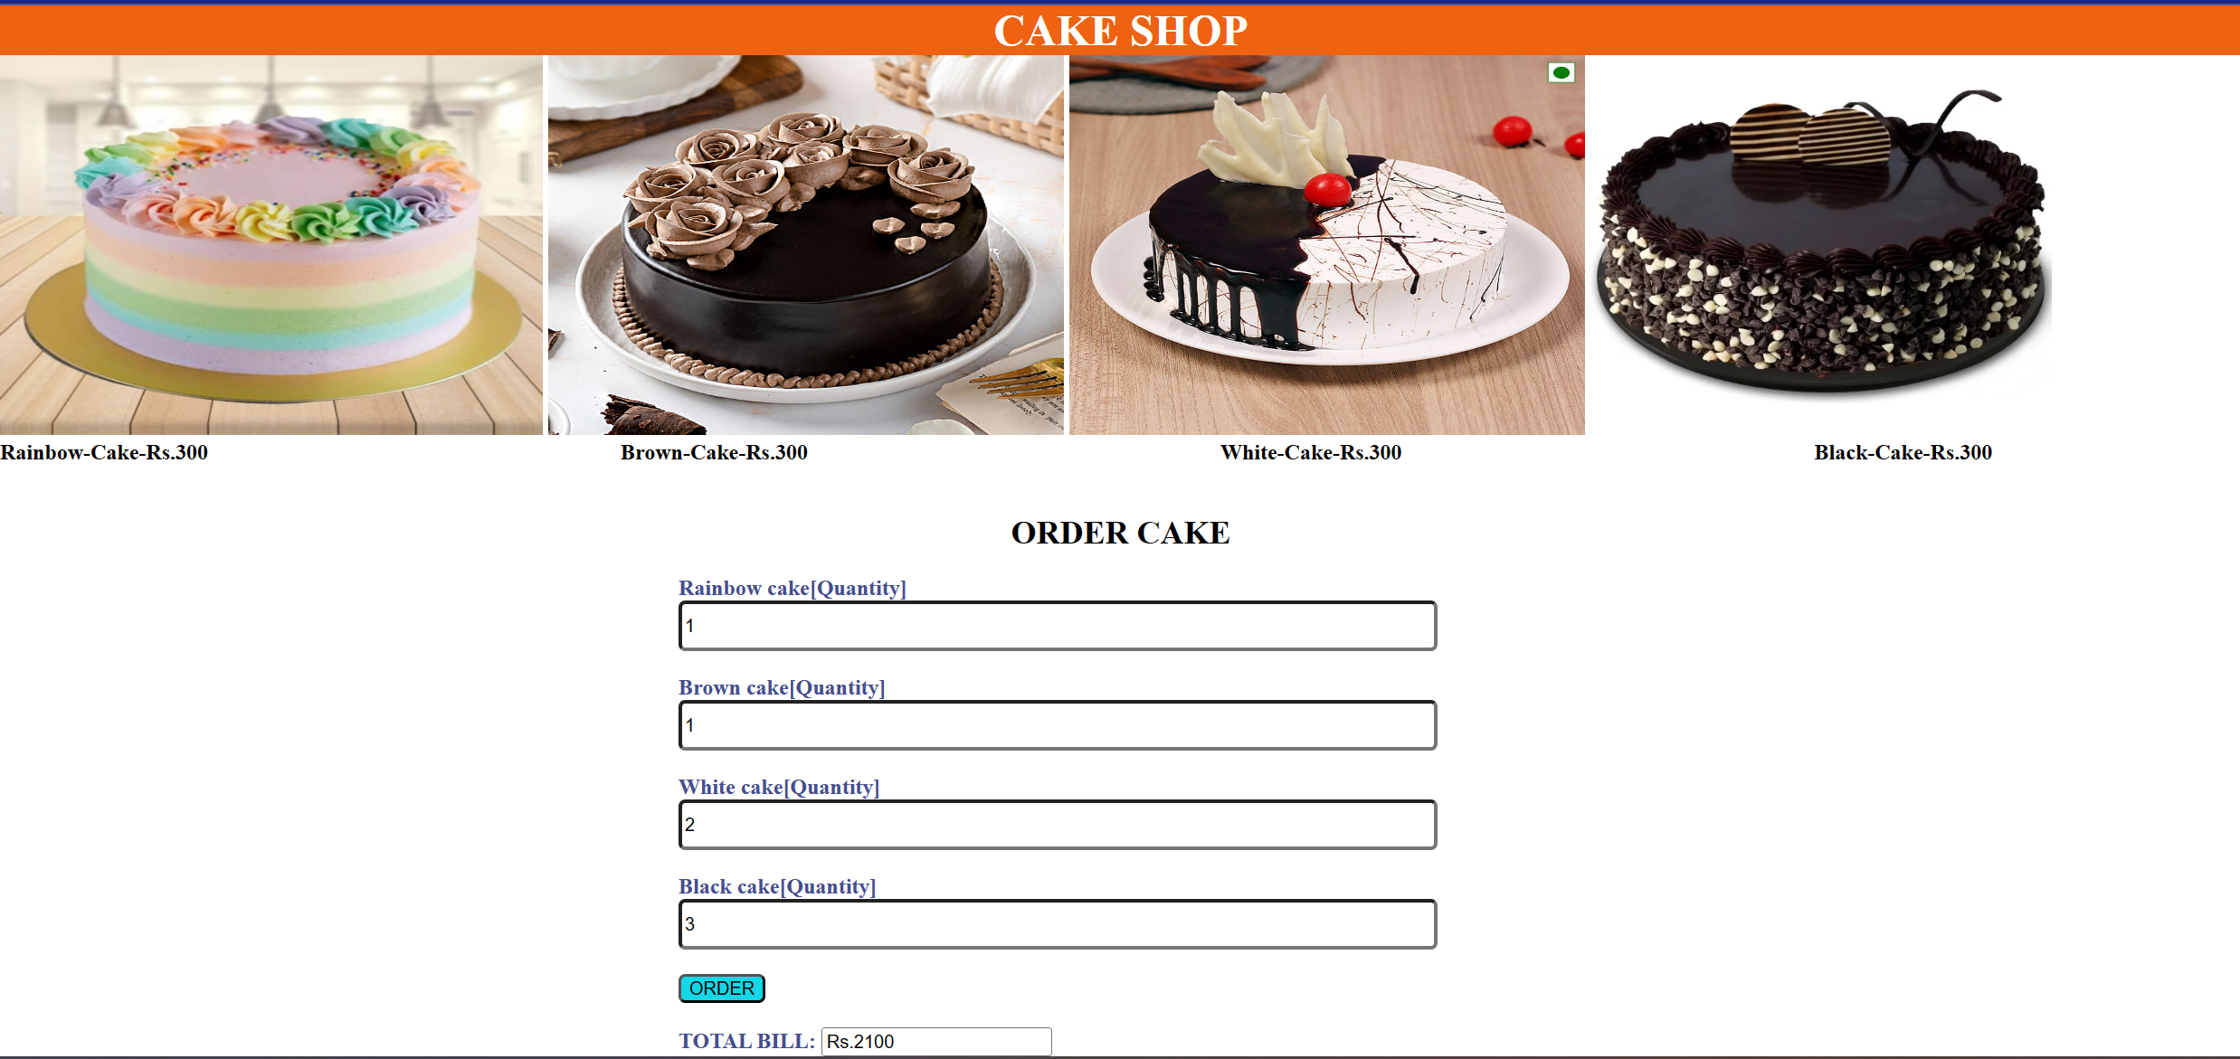

**Question2**

**HTML File:**

<!DOCTYPE html>

<html>

<head>

<title>Question 2 Experiment 7</title>

<script src="https://ajax.googleapis.com/ajax/libs/jquery/3.5.1/jquery.min.js"></script>

<link href="https://cdn.jsdelivr.net/npm/bootstrap@5.3.1/dist/css/bootstrap.min.css" rel="stylesheet">

<script src="https://cdn.jsdelivr.net/npm/bootstrap@5.3.1/dist/js/bootstrap.bundle.min.js"></script>

<style>

.box {

width: 100px;

height: 100px;

background-color: red;

margin: 10px;

border: 2px solid black;

border-radius: 20px;

}

.container {

display: flex;

}

button{

margin-left: 5px;

margin-top: 140px;

}

</style>

</head>

<body>

<h1>Customizer</h1>

<div class="container">

<div class="box"></div>

<div class="box"></div>

<div class="box"></div>

<div class="box"></div>

</div>

<button class="btn btn-primary" id="cssBtn">Change CSS</button>

<button class="btn btn-primary" id="showBtn">Show</button>

<button class="btn btn-primary" id="hideBtn">Hide</button>

<button class="btn btn-primary" id="toggleBtn">Toggle</button>

<button class="btn btn-primary" id="fadeinBtn">Fade In</button>

<button class="btn btn-primary" id="fadeoutBtn">Fade Out</button>

<button class="btn btn-primary" id="fadeToggleBtn">Fade Toggle</button>

<button class="btn btn-primary" id="slideUpBtn">Slide Up</button>

<button class="btn btn-primary" id="slideDownBtn">Slide Down</button>

<button class="btn btn-primary" id="slideToggleBtn">Slide Toggle</button>

<button class="btn btn-primary" id="animateBtn">Animate</button>

<script>

$(document).ready(function() {

var colors = ["violet", "yellow", "blue"];

var currentColorIndex = 0;

$("#cssBtn").click(function() {

$(".box").css("background-color", colors[currentColorIndex]);

currentColorIndex = (currentColorIndex + 1) % colors.length;

});

$("#showBtn").click(function() {

$(".box").show();

});

$("#hideBtn").click(function() {

$(".box").hide();

});

$("#toggleBtn").click(function() {

$(".box").toggle();

});

$("#fadeinBtn").click(function() {

$(".box").fadeIn();

});

$("#fadeoutBtn").click(function() {

$(".box").fadeOut();

});

$("#fadeToggleBtn").click(function() {

$(".box").fadeToggle();

});

$("#slideUpBtn").click(function() {

$(".box").slideUp();

});

$("#slideDownBtn").click(function() {

$(".box").slideDown();

});

$("#slideToggleBtn").click(function() {

$(".box").slideToggle();

});

$("#animateBtn").click(function() {

$(".box").animate({padding: '+=50px'}, 2000);

});

});

</script>

</body>

</html>

**OUTPUT**

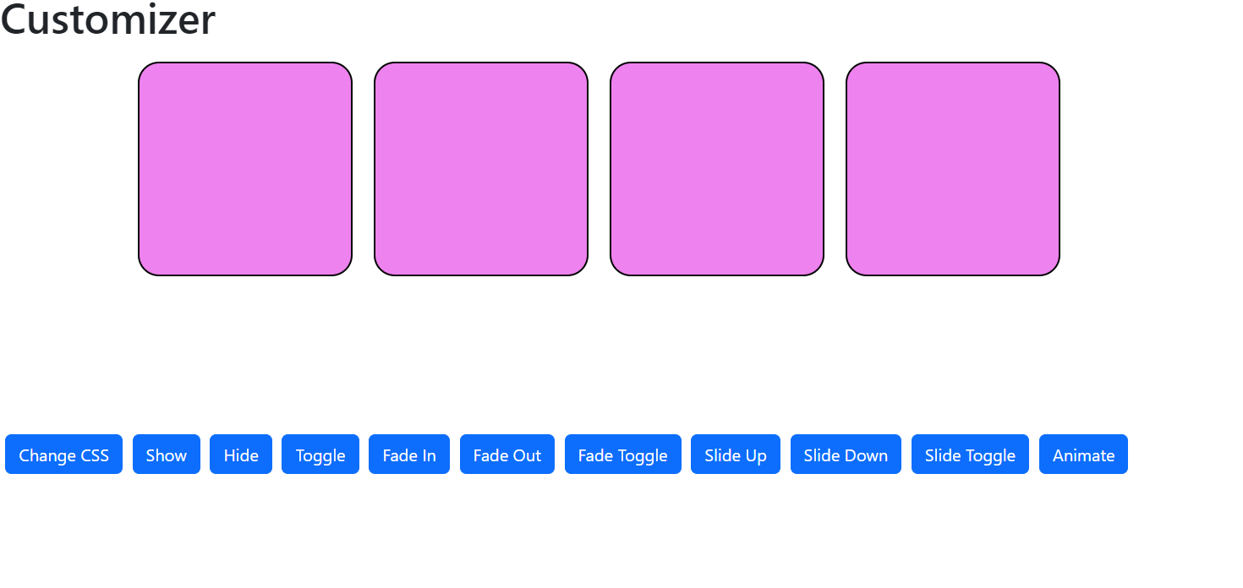

**Result**

Thus, a web page using HTML, CSS, JQuery actions has been created and verified successfully.